# **OPTIMISING THE EFFICACY OF TIME-LIMITED INTERVENTIONS FOR EPIDEMIC CONTROL**

**Aim of Paper/Chapter – Questions to Explore w/ Modelling**

* How can we best implement time-limited social distancing measure strategies?
* Does an optimum exist for “controllable” parameters?
* How much room for error is there with the optimums?

**Take Home Messages from the Results**

* The way you implement social distancing measure strategies has a significant effect on the resulting epidemic curve – both for single and repeated interventions.
* There is an optimum intervention trigger timing which can minimise adverse outcome measures.
  + However, this timing is very narrow and likely not realistic or achievable – small room for error.
* There is an optimum for the intervention strength and duration.
  + Generally, if non-optimal parameters are selected, it is better to be too strong and to introduce the intervention for too long than to do the opposite.
* The interplay between these “controllable” parameter matters a lot – changing one parameter can shift the optimum for another.
  + For example, the longer an intervention is extended, the more you can make up for having a non-optimal trigger point (in terms of minimising adverse outcome measures).
* The interplay for parameters controlling repeated intervention is also very complex.
  + Generally, the parameters controlling the 1st intervention are much more important (timing, length, R0 strength)
  + i.e – it is much worse getting the 1st intervention wrong than it is getting the 2nd intervention wrong.

**RESULTS**

To explore different approaches to introduce SDMs into a population, five intervention scenarios were considered. Each of these differing with regards to the “shape” of the beta reductions over the explored intervention duration. We explored these interventions in the context of a hypothetical COVID-19 outbreak. The five interventions were all assumed to reduce the transmission rate (beta)of SARS-COV-2 from a baseline value of x.xx, representing reductions in human-to-human interactions. However, the magnitude of each intervention over the intervention duration remained similar across each scenario. This was achieved by doubling the length of interventions which do not constantly reduce beta during the intervention period.

1. Instantaneous and constant reduction to beta=x.xx for 12 weeks, followed by an instantaneous return to baseline beta = x.xx.
2. Instantaneous reduction to beta=x.xx followed by a gradual “ramp-down” back to baseline beta after 24 weeks.
3. Gradual linear “ramp-up” to beta = x.xx over 24 weeks, followed by an instantaneous return to baseline beta.
4. Gradual linear “ramp-up” to beta=x.xx over 12 weeks, followed by a gradual “ramp-down” back to baseline beta after an additional 12 weeks.
5. Three pulsed, instantaneous reductions to beta =x.xx for 4 weeks each over a 24-week period. Each 4-week pulsed intervention is separated by an instantaneous return to baseline beta for 4 weeks.
   1. Pulsing occurs at the following fractional intervals of the total intervention period: Period 1: (0 – 0.1667), Period 2: (0.333 – 0.5) and Period 3: (0.667 – 0.8333).
   2. **FIND A MATHEMATICAL-SAVVY WAY TO DESCRIBE THIS**

**Analysis 1**

An intervention date of 71 days was chosen to trigger each intervention, representing an infectious fraction of I(t) = 0.027 (**WHY**). Infections were seeded into the population by modelling an initial infectious fraction of I(0) = 0.0001. We explored the effect of all five interventions on the trajectory of a COVID-19 epidemic curve (**Figure 1**).

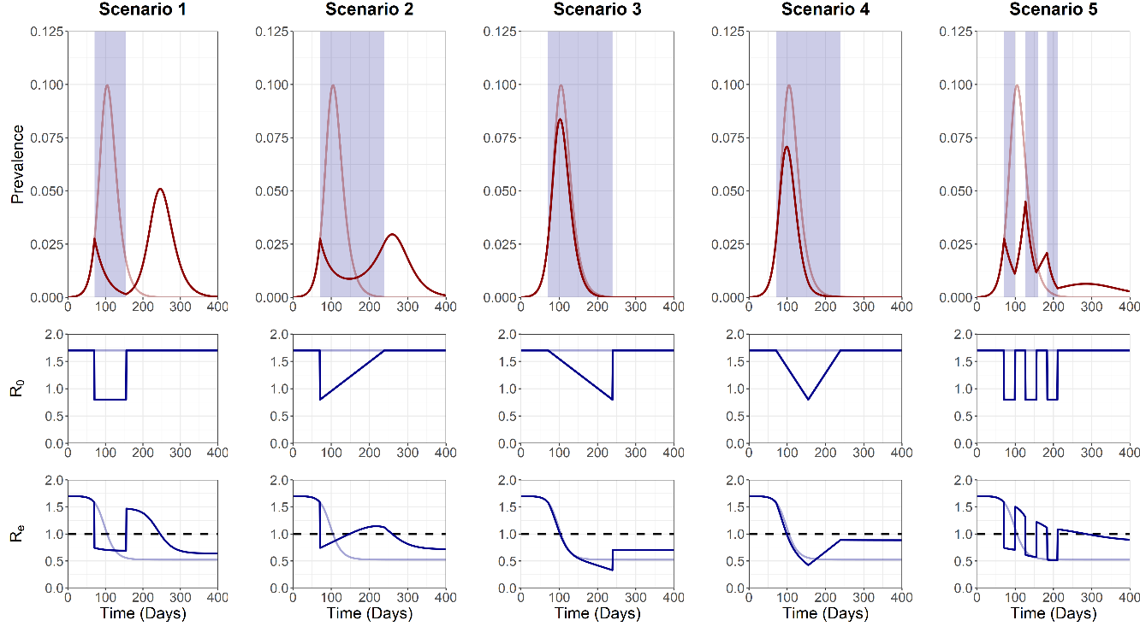

**Figure 1. Trajectory plots for the epidemic curve, beta (or β(t)) reductions and Re, for the five intervention scenarios**. Opaque red and blue lines depict unmitigated epidemic curve dynamics.Blue shading on the trajectory plot indicates the period of the intervention. Dotted black line on the Re plot denotes the threshold for sustained epidemic growth.

Interventions 1, 2 and 5 resulted in sharp decreases to the prevalence of COVID-19, resulting in Re < 1. This was followed a “second wave” in scenario 1 and 2, due to the cessation of the intervention and Re > 1. By pulsing the scenario 5 intervention, second wave dynamics do not occur. Instead, controlled reductions to the model β(t) allow for brief opportunities for community-immunity to build up (Re > 1), before being quickly supressed through another β reduction (Re < 1). Under the baseline parameters considered we observed an I(t) peak of **X (at day X)**, **X (at day X)** and **X (at day X)**, and a total cumulative incidence of **X**, **X** and **X** for intervention 1, 2 and 5 respectively.

Scenarios where gradual “ramping-up” was present (interventions 3 and 4) slowly reduced Re over time. Cessation of transmission can be mostly attributed to build up of “natural” community-immunity rather than through the intervention, with the largest reductions in β(t) (or Re) occurring well past the epidemic peak and having a limited effect on transmission dynamics. We observed similar dynamics in the unmitigated outbreak in these scenarios. Under the baseline parameters considered, an I(t) peak of **X (at day X)** and **X (at day X)**, and a total cumulative incidence of **X** and **X** was observed for intervention 3 and 4 respectively.

To ensure the total magnitude of the reduction in each scenario was the same over the , the length of scenario 2, 3, 4 and 5 were doubled relative to scenario 1. An alternative approach was assessed by keeping the length of the intervention static but doubling the magnitude of β(t)reductions observed in scenario 2, 3, 4 and 5, relative to scenario 1 (**Figure S1**). This alternative method resulted in qualitatively different epidemic curves compared to the original analysis (**Figure 1**). Either method is plausible when considering potential intervention scenarios, but we argue it is more plausible to alter the length of an intervention in comparison to altering the magnitude of transmission reductions **(BASED ON WHAT)**. Therefore, the original approach of doubling the length of scenario 2, 3, 4 and 5 was used for all subsequent analysis.

**Analysis 2**

A sensitivity analysis was next conducted to observe the sensitivity of each scenario to model parameters with regards to two outcome measures: 1) The I(t) peak and 2) the total cumulative incidence (over the 365-day simulation). We explored these outcome measures with regards to three model parameters: 1) Intervention trigger day, 2) the magnitude of intervention β(t)reductions and 3) The duration of each intervention. Each sensitivity analysis was conducted with all other model parameters held at baseline levels (**Figure 2**).

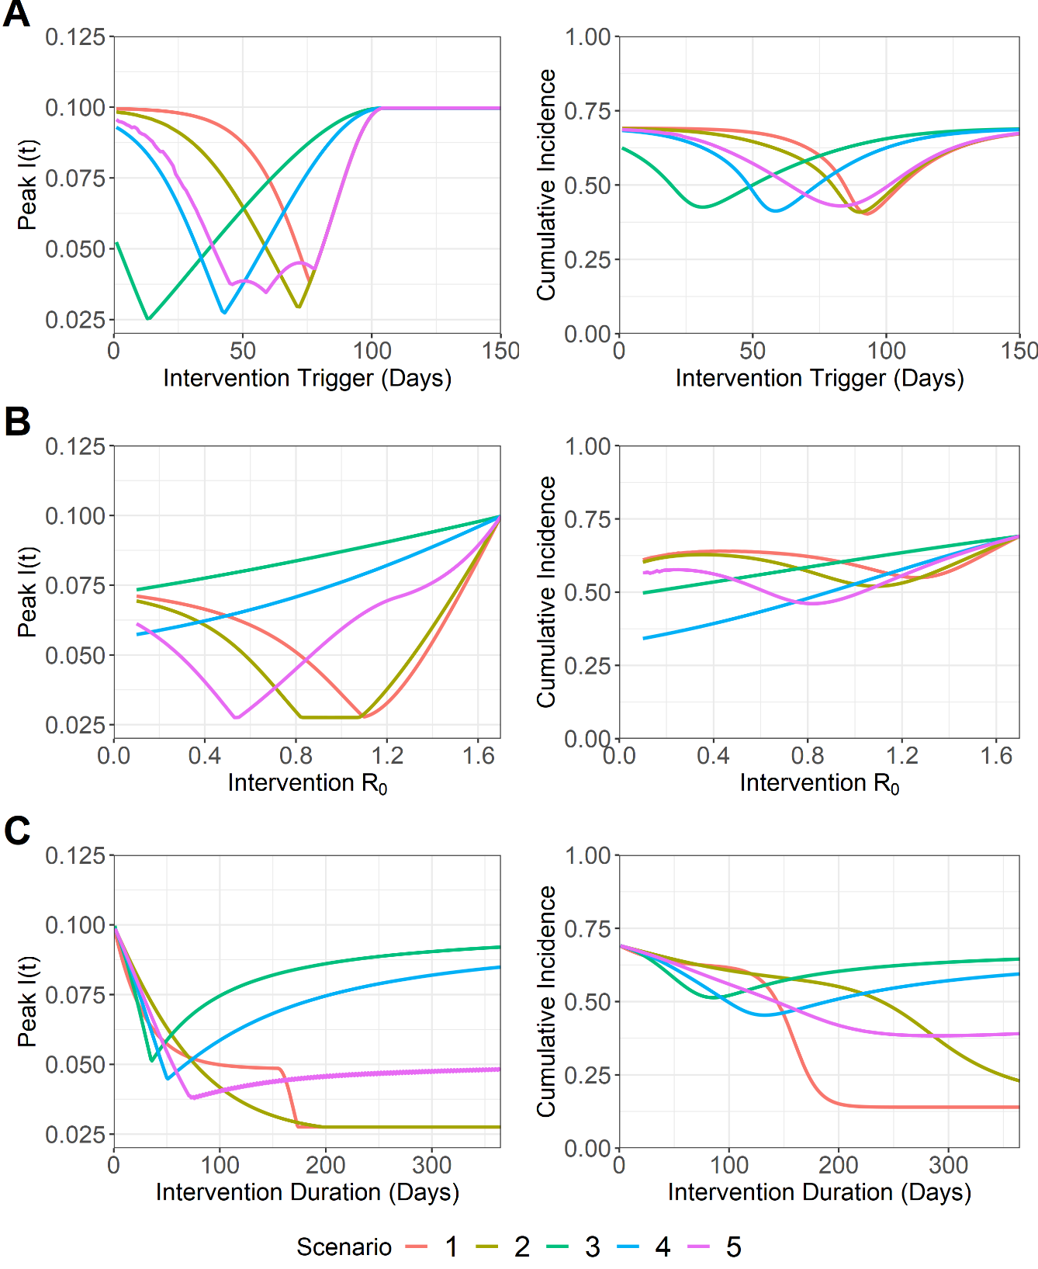

**Figure 2. Sensitivity analysis for I(t) peak and total cumulative incidence for the five intervention scenarios. This was conducted for the following model parameters: A) Intervention trigger day, B) Target** β(t) **magnitude for the intervention and C) Intervention duration (days)**. Note that for A) and B) scenarios are comparable for a specific parameter value, with the duration of scenario 2, 3, 4 and 5 being doubled to ensure similar intervention magnitudes across all scenarios. This was not possible for C) and therefore scenarios are not comparable for a particular intervention duration value. Instead this sensitivity analysis should only be used to identify optimums for each scenario and not for comparison.

An optimum intervention trigger day of **X–to–X** and **X–to–X** days was identified for the five scenarios to minimise the I(t) peak and the total cumulative incidence outcome measures respectively (**Figure 2A**). A narrow optimal parameter space to minimise the I(t) peak was observed for scenarios 1, 2, 3 and 4, with non-optimal deviations from this optimum rapidly increasing the I(t) peak. Scenario 5 possessed a much wider optimal intervention trigger day range (**X-to-X**) and was therefore less sensitive to non-optimal values with regards to the two outcome measures. A wider optimum parameter space was observed with the total cumulative incidence compared to the I(t) peak for all scenarios.

The similar non-optimal gradients on either side of the optimal trigger day for both outcome measures also indicate that intervening too early/late makes little difference. Scenario 3 is an exception, where an early intervention was found to be more desirable to minimise the two outcome measures.

Greater β(t) reductions were found to be optimal for scenario 3 and 4 to minimise I(t) peak and cumulative incidence **(Figure 2B)**. Intermediate β(t) reductions were found to be optimal for scenario 1, 2 and 5, with scenario 2 possessing a large optimal β(t)reduction parameter space to minimise I(t) peak. These optimal ranges for I(t) peak were **X, X-X and X** for scenario 1, 2 and 5, respectively. However, if a non-optimal β(t) reduction is chosen for scenario 1, 2 and 5, it is more beneficial to intervene too strongly, with “greater-than-optimal” β(t) reductions resulting in a lower I(t) peak and total cumulative incidence compared to β(t) reduction values which are too weak.

Scenario 1, 2 and 5 were found to possess no obvious optimal intervention duration, instead following a trend of longer intervention durations resulting in lower I(t) peak and total cumulative incidence (**Figure 2C**). Scenario 3 and 4 were found to possess optimum intervention durations, with **X** and **X** intervention durations minimising the two outcome measures. However, if a non-optimal intervention duration is chosen for these scenarios, it is more beneficial to intervene for too long, with non-optimal increases to the intervention duration resulting in lower I(t) peak and total cumulative incidence, compared to equivalent “shorter-than-optimal” intervention durations.

**Analysis 3**

A sensitivity analysis was next conducted to identify the optimal parameter space to minimise I(t) peak and total cumulative incidence for a multi-dimensional parameter space: 1) Intervention trigger day and 2) Intervention duration (**Figure 3**). We additionally explore the sensitivity of this analysis to the intervention R0 magnitude by ranging this parameter sequentially from 0, 0.5 and 1 (**Figure S2+3**). This allowed us to explore the sensitivity of the system to a third parameter.

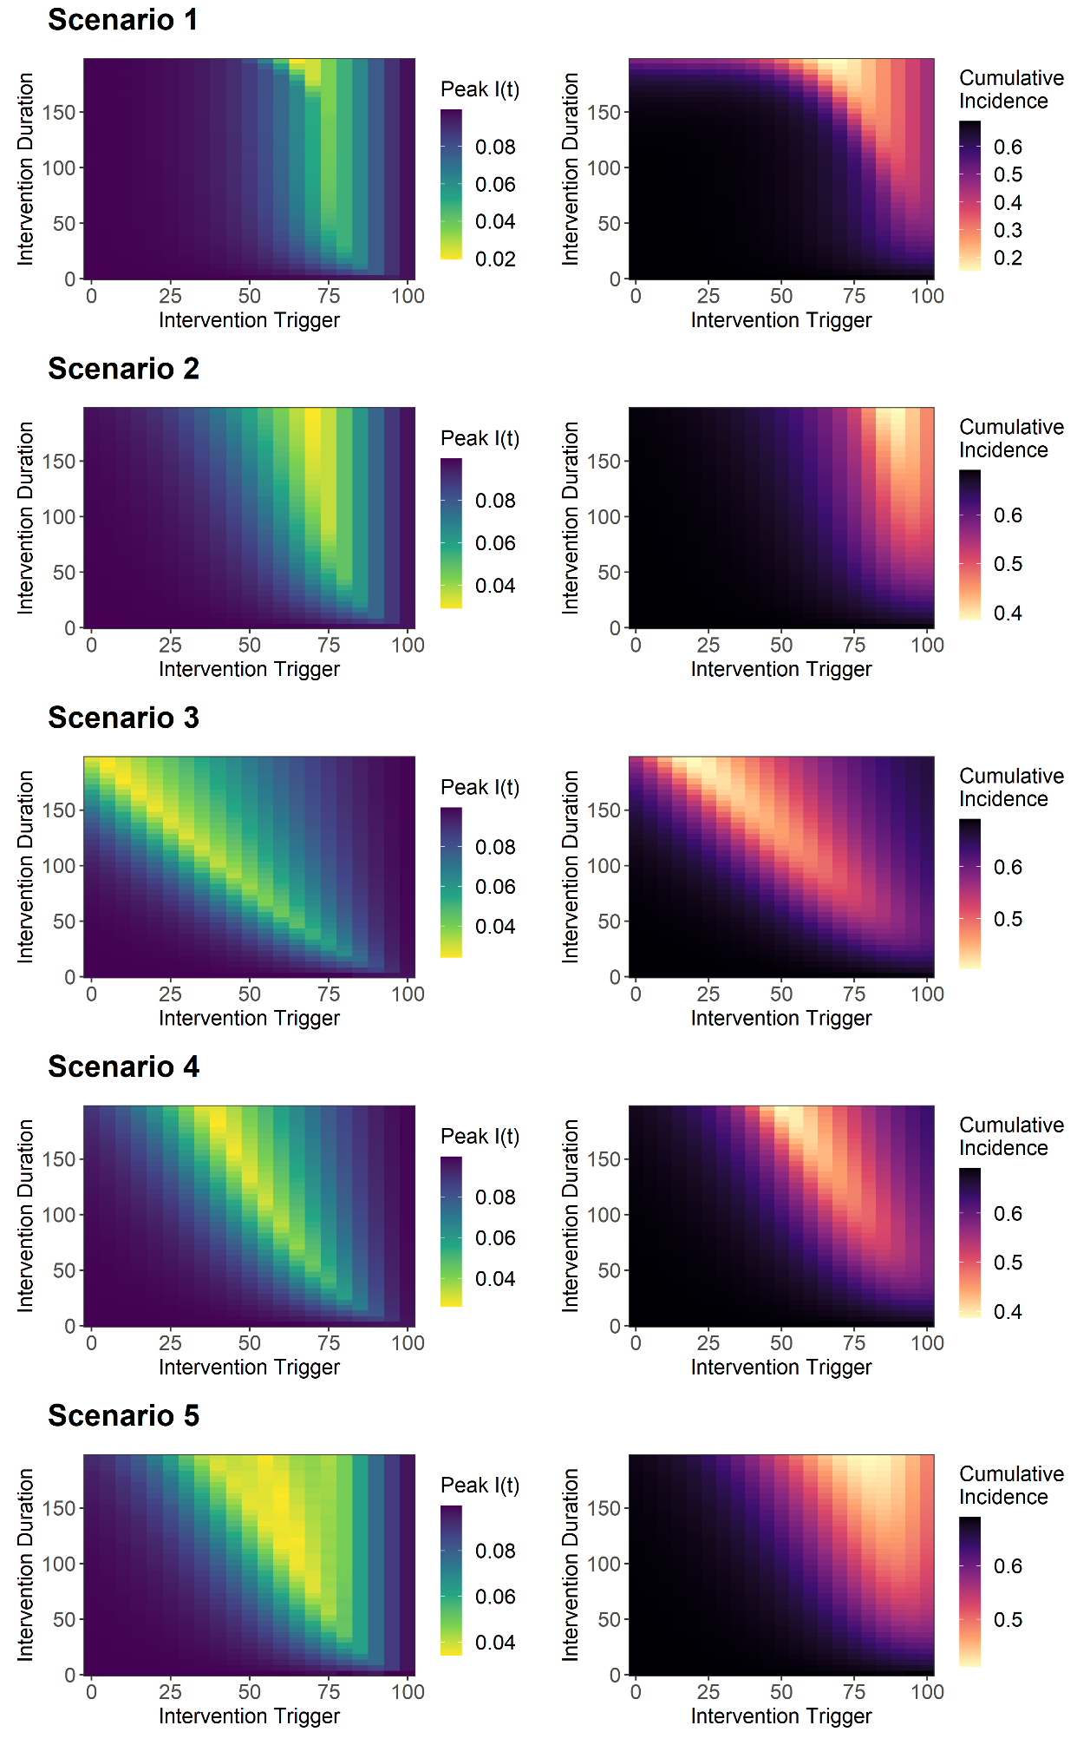

**Figure 3. Sensitivity analysis for I(t) peak and total cumulative incidence for intervention trigger day and the intervention duration. This was explored for the five intervention scenarios.** As intervention duration was an explored parameter, it is not possible to ensure equivalent intervention magnitudes over the considered intervention period for a given parameter space value for scenario 1 vs scenario 2, 3, 4 and 5. The scenario 1 sensitivity analysis should be considered independent and non-comparable to other scenarios for a given parameter combination.

The optimal parameter space for the intervention duration/intervention trigger was identified as **X/X, X/X, X/X, X/X** and **X/X** for the I(t) peak I for scenarios 1, 2, 3, 4 and 5 respectively. The optimal parameter space to minimise the total cumulative incidence was identified as **X/X, X/X, X/X, X/X** and **X/X** for the intervention duration/intervention trigger for scenario 1, 2, 3, 4 and 5 respectively. Similar agreement was found between the optimal parameter space to minimise the I(t) peak and the total cumulative incidence. This phenomenon was identified across all five scenarios.

Scenario 1 and 2 were found to favour a later intervention trigger (how much?) and a moderate-to-high intervention duration (what is moderate to high?). In contrast, as the intervention trigger day increased, subsequent decreases in the intervention duration were necessary to maintain the optimal parameter space for scenario 3 and 4. With this trend being almost linear for scenario 3. Scenario 5 was found to possess an optimal parameter space in between these two observations, with a wide optimal parameter space for both I(t) peak and total cumulative incidence.

Interestingly, the longer an intervention duration is extended, the more room for error there is to choose a non-optimal intervention trigger, whilst still returning somewhat minimal I(t) peak and total cumulative incidence. This was found to be consistent across all intervention scenarios, with varying degrees of non-optimal parameter space allowing for relatively minimal adverse outcome measure values.

**MENTION THE β(t) SUPPLEMENTARY ANALYSIS HERE**

**Analysis 4**

The impact of repeated interventions for the five scenarios on the trajectory of the COVID-19 epidemic curve was next explored. Two interventions for each scenario were modelled, with intervention magnitude kept constant at β(t) = x.xx. Intervention duration was limited to 6 and 12 weeks for scenario 1 and 2, 3, 4, and 5 respectively, to best capture the effects of both interventions within the timeframe of the epidemic curve (**Figure 4**) (**WHY**).

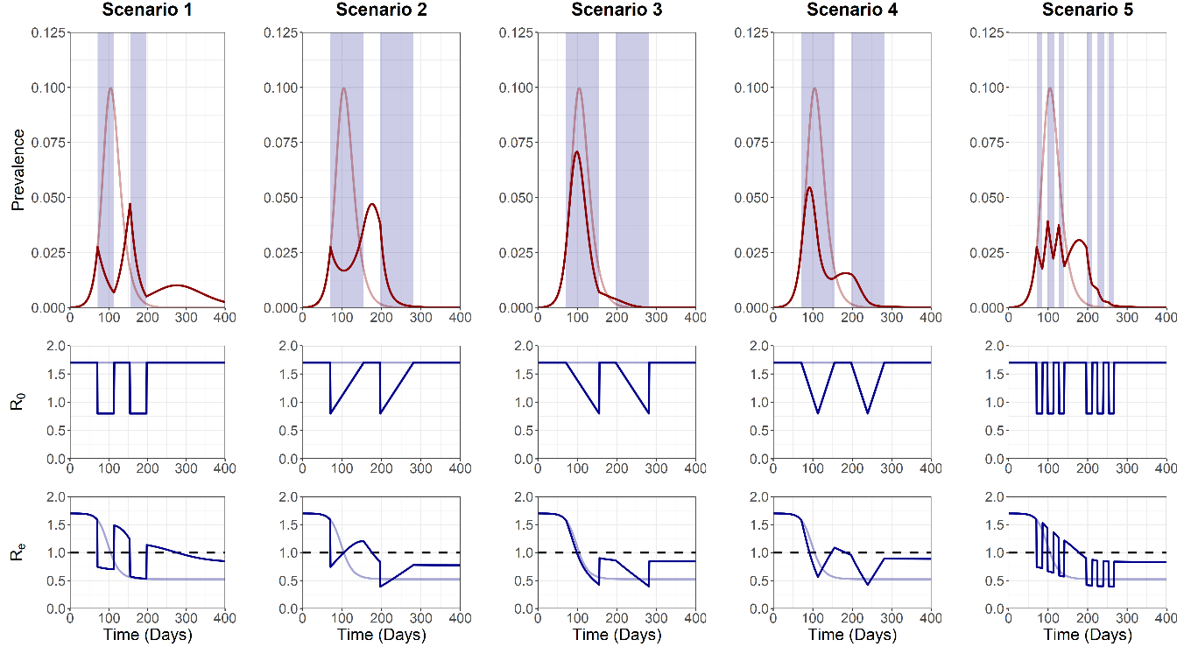

**Figure 4. Trajectory plots for the epidemic curve, intervention associated beta(t)reductions and Re, for the five “double” intervention scenarios.** Partially visible red and blue lines denote unmitigated epidemic curve dynamics.Blue shading on the trajectory plot indicates the duration of the two interventions. Dotted black line on the Re plot denotes the threshold for sustained epidemic growth.

Repeated interventions displayed a high efficacy at minimising the peak I(t) and total cumulative incidence, especially in comparison to the unmitigated outbreak and the single intervention scenarios (**Figure 4**). Peak I(t) was observed at **X (at day X)**, **X (at day X)**, **X (at day X)**, **X (at day X) and X (at day X)** and a total cumulative incidence of **X**, **X, X, X** and **X** for intervention 1, 2, 3, 4 and 5 respectively. Repeated interventions were able to supress the first and second peak in scenario 1 and 2 compared to the single intervention. This is particularly apparent in scenario 1, with the increased population susceptibility following the suppressed 2nd wave pushing Re > 1, allowing a resurgent 3rd bump? to occur at day **~200**.

Scenario 4 possessed a high efficacy of controlling the initial epidemic peak, spreading the peak over a greater period, and allowing a minor second peak as briefly Re > 1. This differed vastly from the single intervention scenario (**Figure 1**). Scenario 3 performed similarly to the unmitigated outbreak, with the largest reductions in beta(t) still occurring past the epidemic peak. Scenario 5 benefited from a greater number of pulsed interventions, albeit for a shorter period, with any increases of Re > 1 rapidly controlled.

Qualitative differences were observed by implementing a doubled R0 intervention magnitude rather than an increased duration (for scenario 2, 3, 4 and 5) to ensure static alterations in R0 over the intervention period across the intervention scenarios (**Figure S4**). However, in line with the single intervention analyses, all subsequent repeated intervention analyses were conducted by doubling the intervention length for scenario 2, 3, 4 and 5 (**DESCRIBE WHY**).

**Analysis 5**

A sensitivity analysis was conducted to explore the optimal parameter space for: 1) Intervention 1 trigger date vs 2) Intervention 2 trigger date. A range of 0–125 days was selected to explore the optimal parameter space for the intervention trigger dates. The intervention 1 trigger date was relative to the start of the simulation and intervention 2 trigger date relative to the end of intervention 1. The optimal parameter space was identified by minimising the I(t) peak and the total cumulative incidence (**Figure 5**)

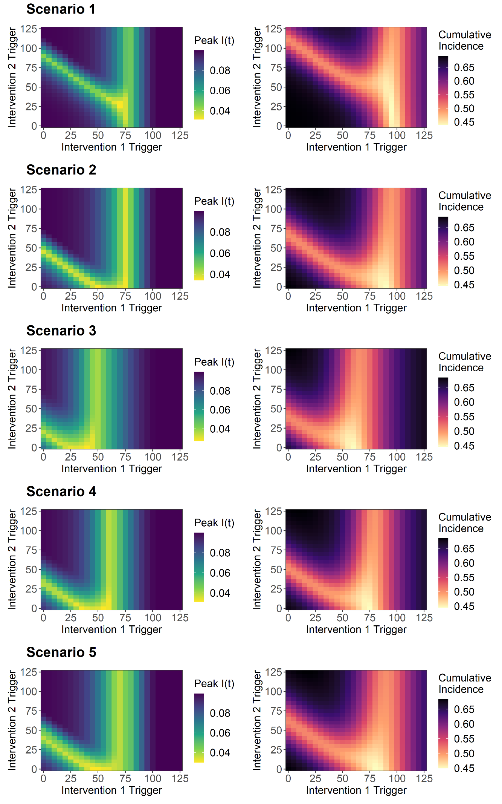

**Figure 5. Sensitivity analysis for I(t) peak and total cumulative incidence for intervention 1 trigger date and intervention 2 trigger date. This was explored for the five intervention scenarios.** To ensure comparable overall magnitude of interventions of over the intervention duration, the intervention duration of Scenarios 2, 3, 4 and 5 were doubled relative to scenario 1 (12 vs 6 weeks). All scenarios are therefore comparable for a given parameter value combination

The optimal parameter space for the intervention 1 trigger and intervention 2 trigger was identified as **X/X, X/X, X/X, X/X** and **X/X** for the I(t) peak for scenarios 1, 2, 3, 4 and 5 respectively. The optimal parameter space to minimise the total cumulative incidence was identified as **X/X, X/X, X/X, X/X** and **X/X** for scenario 1, 2, 3, 4 and 5 respectively. There was general agreement between the optimal parameter space for the I(t) peak and total cumulative incidence for each given intervention scenario.

Scenario 1, 2, 3, 4 and 5 all showed similar optimal parameter spaces, with intermediate intervention 1 trigger date values being optimal to minimise the two outcome measures. At this optimum, a wide range of optimal intervention 2 trigger dates was identified, suggesting that optimising the timing of the 1st intervention is more critical to minimise I(t) peak and total cumulative incidence. Scenario 1 was found to show subtly different dynamics, with a more intermediate intervention 2 trigger date value being optimal.

The sensitivity analysis was expanded to assess the sensitivity of this analysis to two additional parameters: 1) Intervention 1 duration and 2) Intervention 2 duration. These parameters were explored for 3, 6 and 9 weeks (**Figure S5-14**). Altering the intervention length had little effect on the observed transmission dynamics, with increased durations of intervention 1 marginally shifting the optimal trigger for intervention 2 to a more intermediate value. This was common for both the I(t) peak and total cumulative incidence outcome measures.

A sensitivity analysis was next conducted to explore the optimal parameter space for: 1) Intervention 1 R0 reduction and 2) Intervention 2 R0 reduction to minimise I(t) peak and total cumulative incidence outcome measures. The magnitude of R0 reductions for both interventions were ranged from 0–1.7 (**Figure 6**).

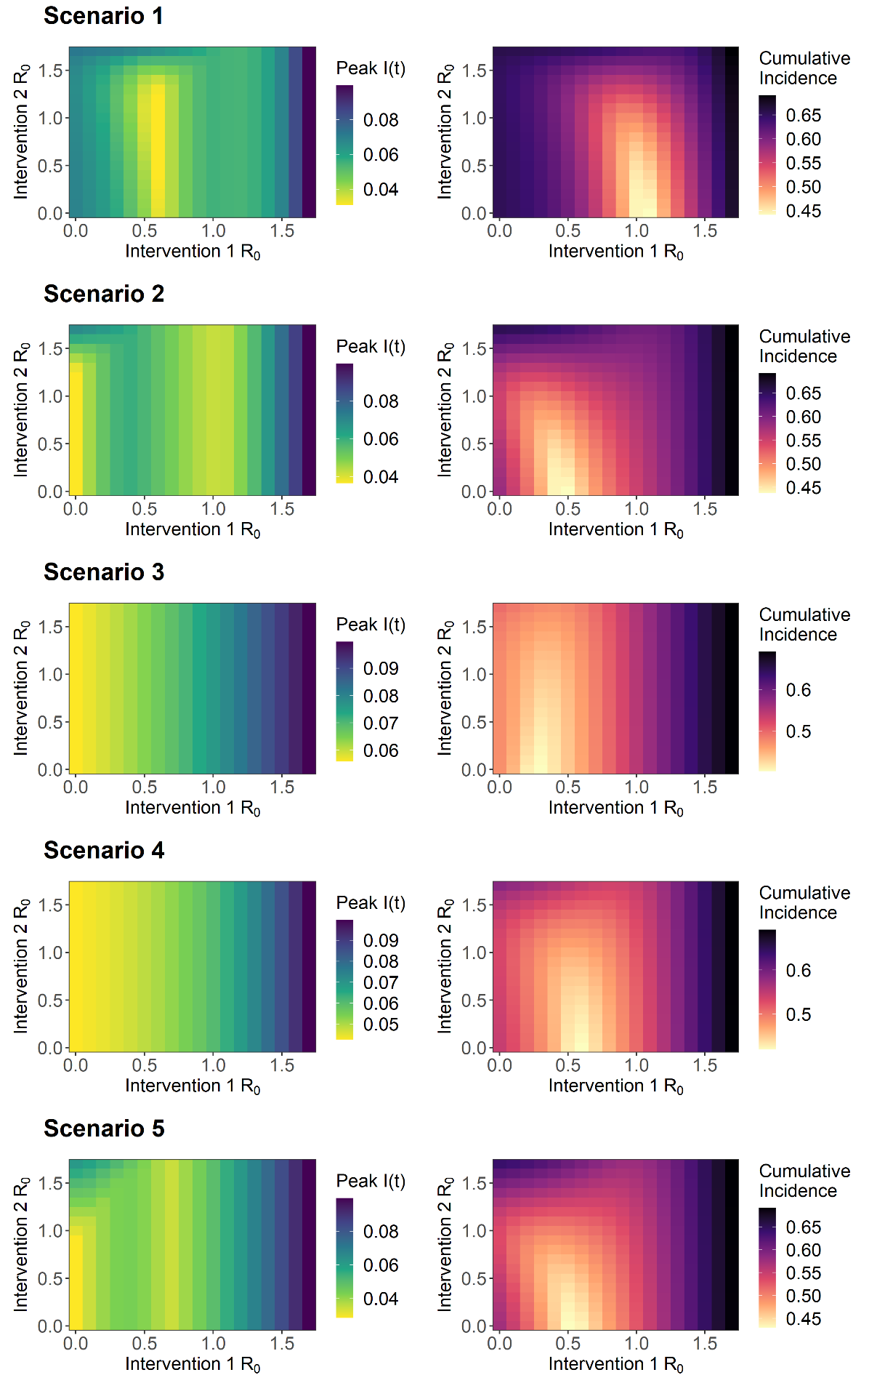

**Figure 6. Sensitivity analysis for I(t) peak and total cumulative incidence for the magnitude of the intervention 1 R0 reductions and intervention 2 R0 reductions. This was explored for the five intervention scenarios.** To ensure comparable overall magnitude of interventions of over the intervention duration, the intervention duration of Scenarios 2, 3, 4 and 5 were doubled relative to scenario 1 (12 vs 6 weeks). All scenarios are therefore comparable for a given parameter value combination.

The optimal parameter space for the magnitude of R0 reductions for intervention 1 and intervention 2 was identified as **X/X, X/X, X/X, X/X** and **X/X** for the I(t) peak for scenarios 1, 2, 3, 4 and 5 respectively. The optimal parameter space to minimise the total cumulative incidence was identified as **X/X, X/X, X/X, X/X** and **X/X** for scenario 1, 2, 3, 4 and 5 respectively.

The optimal parameter space for scenario 2, 3, 4 and 5 favoured a strong reduction during intervention 1, and with the strength of intervention 2 being of less concern, with a wide optimal parameter space being observed for a given magnitude of intervention 1 R0 reduction. Interestingly, an additional intermediate optimal value of **X** and **X** for the intervention 1 R0 reduction parameter was also observed for scenario 2 and 5.

The optimum parameter space to minimise the total cumulative incidence was dissimilar to the parameter space to minimise the I(t) peak. Across all scenarios, more intermediate magnitudes of intervention 1 R0 reductions were favoured, and with stronger R0 reductions needed to intervention 2 to minimise the total cumulative incidence outcome measure.

The optimal parameter space for scenario 1 favoured intermediate reductions of R0 = 0.6 to intervention 1 to minimise I(t) peak, with this optimum being relatively narrow in comparison to other scenarios. This was similarly observed with the cumulative incidence outcome measure. To explore this phenomenon further, the epidemic curves of scenario 1 and 2 interventions were assessed under differing levels of intervention 1 and 2 R0 reductions (**Figure S15-16**).

The constant nature of scenario 1 interventions was found to prevent the build-up of herd immunity, with a stronger intervention delaying the epidemic peak due to the relatively large fraction of susceptibles present after the cessation of the interventions. Adopting an intermediate strength R0 reduction allows for immunity to be built up in the population, subsequently dampening the epidemic peak. Scenarios which possessed a ramping period or some intermittent pulsing where the intervention is relaxed (scenario 2, 3, 4 and 5), a controlled number of infections can still occur even under strong R0 reductions, allowing for peak reductions under these circumstances. This “intermediate” effect was most effective when applied to the 1st intervention.

This sensitivity analysis was also expanded to assess the effect of 1) Intervention 1 duration and 2) Intervention 2 duration on the optimal R0 reduction parameter space. Interestingly, increasing intervention 1 duration promotes a more intermediate optimal intervention 1 R0 reduction to minimise the I(t) peak (**Figure S17-21**). This was effect was similarly observed with the total cumulative incidence outcome measure (**Figure S22-26**). This phenomenon was most apparent in scenario 1 sensitivity analysis (**Figure S17**).